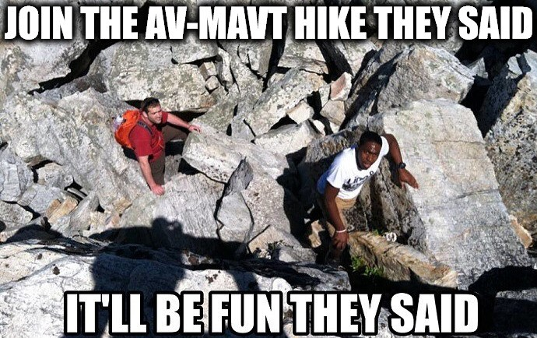
AV-MAVT Hike on June 19th to Buochserhorn

Join us on a hike to the Buochserhorn in the canton of Nidwalden, enjoy some stunning views on the beautiful Vierwaldstättersee and socialize with other nice people from the D-MAVT! The hike will start and end from the Niederrickenbach Dorf cable car station and take just under 4 h (~ 9 km, 730 m uphill elevation, 730 m downhill elevation). It should be suitable for beginners, as well as seasoned mountaineers :-)
Please find all the relevant details below and make sure to register until Wednesday, June 16th via the link provided. We hope to see many of you there!
Date: Saturday, June 19th 2021
Departure from Zurich HB: ~ 8 AM
Return to Zurich HB: ~ 5-6 PM
Total cost of public transport tickets
(covered by participants): ~ 45 CHF (half-fare)
Registration deadline: Wed, June 16th
Link to registration form: https://bit.ly/2RR9Klb
Note on Covid safety:
To make this event as safe as possible for everyone, we ask each participant to take a Covid test within 72 h before the hike. This could be a rapid antigen self-test which can be obtained for free from many pharmacies or a PCR test which is also offered free of charge to all ETH members (https://covmass.ethz.ch/). Thank you for your understanding and cooperation!

